卡通人物

AI 生成的内容可能不正确。

AD 685 Quantitative Methods for Financ Term Project

**Yuxuan Chen U76697870**

图标

AI 生成的内容可能不正确。

**1. Data selection**

For this project I selected The Coca-Cola Company (KO). It is an American multinational beverage corporation headquartered in Atlanta, Georgia. A quick search on Yahoo Finance shows its Market Cap (intraday) is USD 299.663 billion (retrieved 18 Jun 2025). According to the project instructions, KO falls under the “large-cap” category (market capitalization between $100 billion and $200 billion). Therefore, I have chosen to use the SPDR S&P 500 ETF (SPY) as the benchmark. In addition to the benchmark, I selected SPDR Gold Shares (GLD) as my second explanatory variable (denoted as X2). GLD is an exchange-traded fund (ETF) designed to track the price of gold bullion. As the Coca-Cola Company operates on a global scale and is subject to commodity and macroeconomic fluctuations, the inclusion of gold returns provides a relevant economic signal.

**2. Calculate daily earnings and related statistics**

Because most of the estimations will refer to returns rather than prices, I choose to use logarithmic return:

Log-returns are additive and symmetric, closely approximate simple returns for small moves, and exhibit distributions closer to normality, making them ideal for multi-period quantitative asset analysis. The price data for GLD and SPY are also converted to daily logarithmic yields to maintain consistency with the yield calculation method used by KO.

By using Python, I obtained a series of statistics for the stock returns (see Table 1).

|  |  |
| --- | --- |
| **Name** | The Coca-Cola Company |
| **Ticker** | KO |
| **Mean** | 0.000193 |
| **Median** | 0.000958 |
| **Sample standard deviation** | 0.015624 |
| **Minimum** | -0.101728 |
| **Maximum** | 0.062783 |
| **Sample skewness** | -0.841427 |
| **Sample kurtosis** | 6.966093 |
| **Starting date** | 2020/1/3 |
| **Final date** | 2022/12/30 |

**Table 1** Stock Return Statistics

图表, 折线图

AI 生成的内容可能不正确。**Figure 1**: Daily Log Returns KO vs SPY

**3. OLS regression and Newey–West estimator**

**3.1 Ordinary Least Squares Regression**

Ordinary Least Squares (OLS) regression is a method for estimating the relationship between a dependent variable and one or more independent variables by minimizing the sum of squared residuals (differences between observed and predicted values).

OLS finds the set of coefficients that minimize:

**3.2 Newey–West estimator**

In time-series regressions, residuals often display heteroskedasticity and autocorrelation, violating classical OLS assumptions. This makes standard errors invalid, compromising inference.

The Newey–West estimator corrects this by adjusting the OLS covariance matrix to provide robust standard errors.

The general formula is:

where:

For the special case of **Newey–West (1 lag)**:

Therefore, the robust covariance becomes:

**4. Regression Results**

**4.1 Separate data**

First, I separated all the data into two periods:

* First 2 years. This data will be used to “teach” or establish our model.
* Last year. This data will be used to test our model and to “forecast”.

The results are shown on the table below:

|  |  |  |  |  |
| --- | --- | --- | --- | --- |
| **KO-train (2020-2021)** | |  | **KO-test (2022)** | |
| **Mean** | 0.000147 |  | **Mean** | 0.000286 |
| **Median** | 0.000751 |  | **Median** | 0.001399 |
| **Std Dev** | 0.016984 |  | **Std Dev** | 0.012482 |
| **Min** | -0.101728 |  | **Min** | -0.072169 |
| **Max** | 0.062783 |  | **Max** | 0.037942 |
| **Skewness** | -0.81508 |  | **Skewness** | -0.835994 |
| **Kurtosis** | 6.624366 |  | **Kurtosis** | 4.678076 |

**Table 2** KO’s two periods’ statistics

Compared to 2020–2021, KO's log returns in 2022 showed slightly higher average returns, but lower volatility and fewer extreme movements. The return distribution remained slightly left-skewed, but became more stable and closer to normal, as indicated by lower kurtosis. Overall, KO returns in 2022 were calmer and less risky than in the prior two years.

|  |  |  |  |  |
| --- | --- | --- | --- | --- |
| **SPY-train (2020-2021)** | |  | **SPY-test (2022)** | |
| **Mean** | 0.000754 |  | **Mean** | -0.000863 |
| **Median** | 0.001648 |  | **Median** | -0.001815 |
| **Std Dev** | 0.016144 |  | **Std Dev** | 0.015298 |
| **Min** | -0.115887 |  | **Min** | -0.044456 |
| **Max** | 0.086731 |  | **Max** | 0.053497 |
| **Skewness** | -1.061486 |  | **Skewness** | -0.001245 |
| **Kurtosis** | 13.253851 |  | **Kurtosis** | 0.33286 |

**Table 3** SPY’s two periods’ statistics

In 2022, SPY's average and median log returns turned negative, contrasting with the positive returns in 2020–2021. Volatility stayed at a similar level, but extreme movements became much less frequent, as seen from the sharp drop in kurtosis. The distribution also became more symmetric, with skewness moving closer to zero. Overall, SPY returns in 2022 were weaker but more stable.

|  |  |  |  |  |
| --- | --- | --- | --- | --- |
| **GLD-train (2020-2021)** | |  | **GLD-test (2022)** | |
| **Mean** | 0.000341 |  | **Mean** | -0.000031 |
| **Median** | 0.000926 |  | **Median** | 0.000388 |
| **Std Dev** | 0.010643 |  | **Std Dev** | 0.009619 |
| **Min** | -0.05519 |  | **Min** | -0.030162 |
| **Max** | 0.04739 |  | **Max** | 0.030235 |
| **Skewness** | -0.614508 |  | **Skewness** | 0.133872 |
| **Kurtosis** | 3.869966 |  | **Kurtosis** | 0.629863 |

**Table 4** GLD’s two periods’ statistics

GLD’s log returns in 2022 showed slightly lower volatility compared to 2020–2021. The average return turned slightly negative, though the median remained positive, suggesting minimal directional change. Skewness shifted from left-skewed to mildly right-skewed, and kurtosis decreased notably, indicating fewer extreme price moves. Overall, GLD returns in 2022 were more balanced and less volatile than in the previous two years.

**4.2 Stock returns & Intercept**

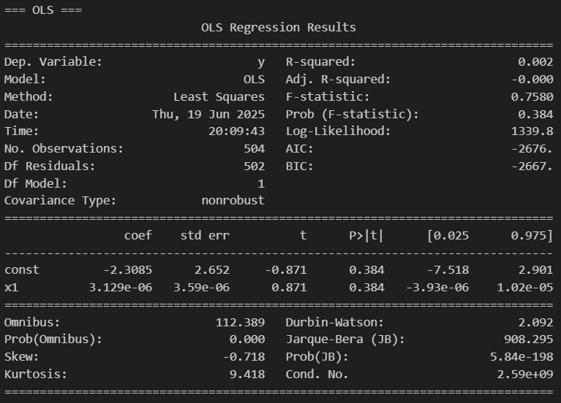

**Figure 2**: KO vs Intercept (OLS)

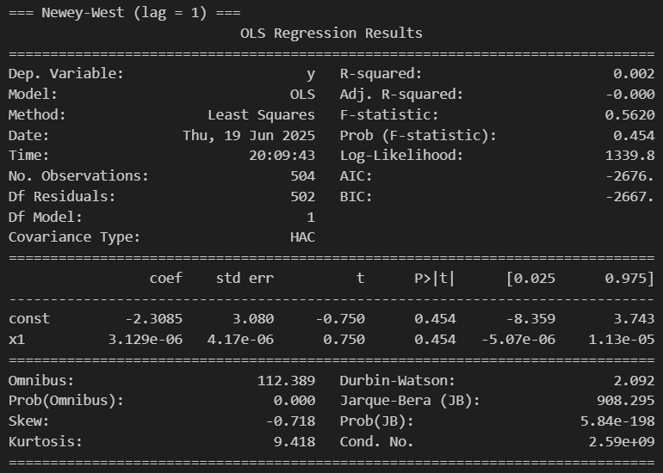

**Figure 3**: KO vs Intercept (Newey-West)

Whether using ordinary OLS or Newey-West, the p-values for Intercept are much greater than 0.05 (0.384 and 0.454) and are not significant.

**4.3 Stock returns & Benchmark returns & Intercept**

文本

AI 生成的内容可能不正确。

**Figure 4**: KO vs SPY & Intercept (OLS)

文本

AI 生成的内容可能不正确。

**Figure 5**: KO vs SPY & Intercept (Newey-West)

In both the OLS and Newey-West regressions, the intercept terms are not statistically significant, with p-values of 0.362 and 0.379, respectively. In contrast, the SPY log return is highly significant in both models, with p-values well below the 0.05 threshold.

**4.4 Stock returns & CRSP returns & Intercept**

文本

AI 生成的内容可能不正确。

**Figure 6**: KO vs CRSP & Intercept (OLS)

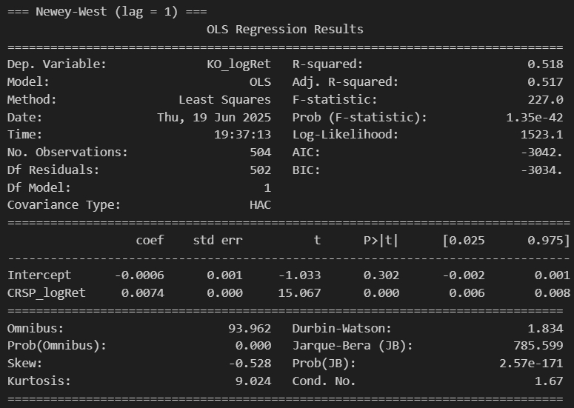

**Figure 7**: KO vs CRSP & Intercept (Newey-West)

In both the OLS and Newey-West regressions, the intercept terms are not statistically significant, with p-values of 0.281 and 0.302, respectively. In contrast, the CRSP log return is highly significant in both models, with p-values far below the 0.05 threshold.

**4.5 Stock returns & Benchmark returns & Gold returns & Intercept**

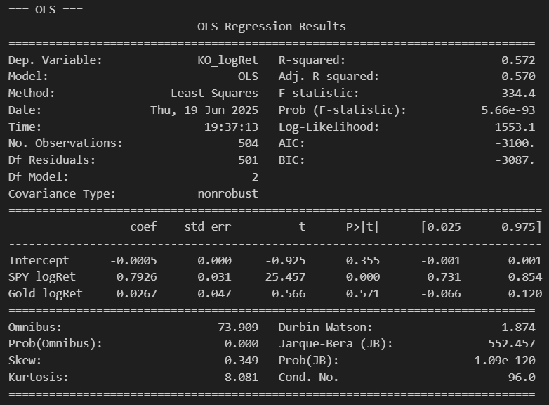

**Figure 8**: KO vs SPY & Gold & Intercept (OLS)

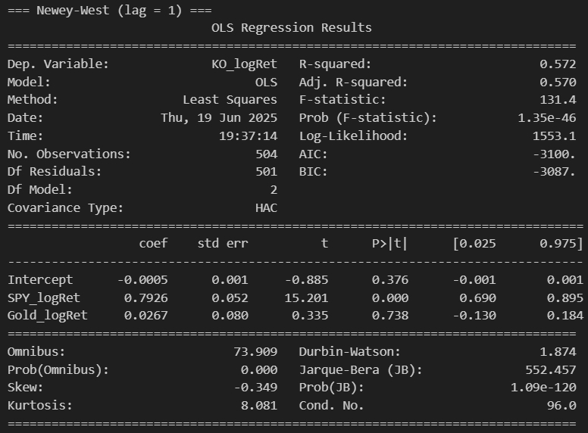

**Figure 9**: KO vs SPY & Gold & Intercept (Newey-West)

In both the OLS and Newey-West regressions, the intercept terms are not statistically significant, with p-values of 0.355 and 0.376, respectively. The SPY log return remains highly significant across both models, with p-values well below 0.05, confirming its strong predictive power for KO’s returns. However, the Gold log return is not statistically significant in either model (p-values of 0.571 and 0.738), suggesting that gold returns do not provide meaningful additional explanatory power for KO’s daily return.

**4.6 Stock returns & CRSP returns & Gold returns & Intercept**

文本

AI 生成的内容可能不正确。

**Figure 10**: KO vs CRSP & Gold & Intercept (OLS)

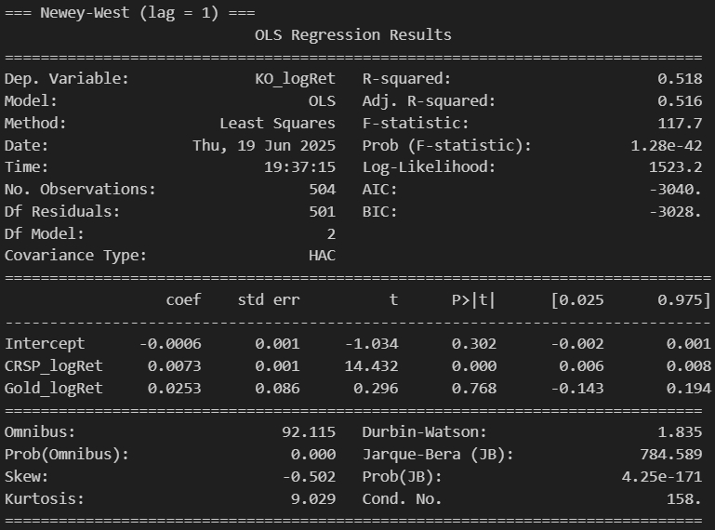

**Figure 11**: KO vs CRSP & Gold & Intercept (Newey-West)

In both the OLS and Newey-West regressions, the intercept terms are not statistically significant, with p-values of 0.276 and 0.302, respectively. The CRSP log return is highly significant in both models (p-values < 0.001), confirming its strong explanatory power for KO’s daily returns. However, the Gold log return is not statistically significant (p = 0.614 in OLS, and 0.768 in Newey-West), indicating that gold returns do not significantly contribute to explaining KO’s return variation.

In summary, no variable changes its significance status when comparing OLS and Newey-West t-statistics.

**5. Results Analysis**

|  |  |  |  |  |
| --- | --- | --- | --- | --- |
| **Regression of KO vs SPY, GLD and CRSP** | | | | |
| **Sample: Jan 01, 2020 - Jan 01, 2025** | | | | |
|  | **1** | **2** | **3** | **4** |
| Intercept | -0.0005 | -0.0006 | -0.0005 | -0.0006 |
| (OLS s.e.) | 0.0000 | 0.0010 | 0.0000 | 0.0010 |
| (NW s.e.) | 0.0010 | 0.0010 | 0.0010 | 0.0010 |
| S&P500 | 0.7953 | - | 0.7926 | - |
| (OLS s.e.) | 0.0310 | - | 0.0310 | - |
| (NW s.e.) | 0.0500 | - | 0.0520 | - |
| CRSP | - | 0.0074 | - | 0.0073 |
| (OLS s.e.) | - | 0.0000 | - | 0.0000 |
| (NW s.e.) | - | 0.0000 | - | 0.0010 |
| X2 | - | - | 0.0267 | 0.0253 |
| (OLS s.e.) | - | - | 0.0470 | 0.0500 |
| (NW s.e.) | - | - | 0.0800 | 0.0860 |
| R2 Adjusted | 0.571 | 0.517 | 0.57 | 0.516 |
| s.e. Reg | 0.01113 | 0.01181 | 0.01114 | 0.01182 |
| NOBS | 504 | 504 | 504 | 504 |

**Table 5** 4 Estimated Regressions

In this project, I compare two alternative specifications for modeling the daily log returns of The Coca-Cola Company (KO): Model (1), which uses the SPDR S&P 500 ETF (SPY) as the market proxy, and Model (2), which uses CRSP. Although both market return variables are highly statistically significant (p-values < 0.001), I find that Model (1) offers stronger explanatory power with an R-squared of 0.571, compared to 0.517 in Model (2). This suggests that SPY better captures market-related movements in KO returns over the sample period. While I do not observe strong evidence of omitted variable bias in either model, I acknowledge that other macroeconomic factors, such as gold prices or interest rates, could influence KO’s returns. To address this possibility, I estimate additional models that include gold returns as an explanatory variable.

In Models (3) and (4), I incorporate gold returns alongside SPY and CRSP, respectively. In both models, the market return variables remain statistically significant, while the gold return is not (p-values well above 0.05). Model (3) yields the highest R-squared (0.572), which confirms that SPY is a more effective market benchmark in this setting. Based on these results, I select **Model (3)** as the preferred specification for explaining KO’s return behavior over the sample period, due to its stronger explanatory power and robustness.